## Compass MED D - Handling One-Time and Automatic Payments for the Medicare Prescription Payment Plan

[Important Notes](#_Toc181612389)

[Accessing the Payments Single-Sign-On (SSO) System from Compass](#_Toc181612390)

[Processing a One-Time Payment](#_Toc181612391)

[Processing an Automatic Payment](#_Toc181612392)

[Updating Automatic Payment Information](#_Toc181612393)

[Cancelling Automatic Payments](#_Toc181612394)

[Reactivating Automatic Payments](#_Toc181612395)

[Entering a Credit Card Number Using Sycurio](#_Toc181612396)

[Void a One-Time Payment](#_Toc181612397)

[Downtime Process](#_Toc181612398)

[Payment Single-Sign-On (SSO) System Fields & Rules](#_Toc181612399)

[Frequently Asked Questions](#_Toc181612400)

[Resolution Time](#_Toc181612401)

[Related Documents](#_Toc181612402)

**Description:** Instructions for handling payments for the Medicare Prescription Payment Plan using the Payment Single-Sign-On (SSO) system. It covers accessing the SSO system and using it to process one-time and automatic payments, update payment information, and ensure PCI compliance by using Sycurio for entering credit card numbers. Additionally, it outlines alternative payment options and troubleshooting steps in case of system errors or downtime.

|  |
| --- |
| Important Notes |

 Notify the Beneficiary that **InstaMed**, a JP Morgan Chase company, processes Medicare Prescription Payment Plan payments **on behalf of their plan.**

 **All MED D and EGWP CCRs** should assist with **Medicare Prescription Payment Plan** payments.

 It is **not** appropriate to list **full** credit card numbers in any Alert fields or Edit Comment fields. This includes but is not limited to: Support Task comments/notes, Mail Order Alerts, Electronic note pad (e.g., MS Word doc or Notepad file), & Emails. Full credit card numbers may **only** be entered in system-specified credit card number fields using the Sycurio SSO feature. All Alert fields and call recordings are periodically checked for compliance. Users who fail to abide by policy may be subject to disciplinary action.

[Top of the Document](#_top)

|  |
| --- |
| Accessing the Payments Single-Sign-On (SSO) System from Compass |

Perform the following steps to access the Credit Card Single-Sign-On (SSO) system:

|  |  |
| --- | --- |
| **Step** | **Action** |
| **1** | Click the **Medicare Prescription Payment Plan (M3P)** hyperlink in the **Quick Actions** panel on the Member Snapshot Landing Page.    **Result:** The **M3P** tab will open on the **Summary** sub-tab. |
| **2** | For beneficiaries that are opted in to the Medicare Prescription Payment Plan, the **Current Invoice** section will display with both the **One-Time** **Payment** and **Automatic Payment** buttons.   * To make a payment for an invoice amount or outstanding balance, click **One-Time Payment**.   + **Note:** The One-Time Payment button will be disabled if the member is enrolled in automatic payments. * To add a payment method on file that will be automatically charged the amount due each month, click **Automatic Payment**. |
| **3** | **Result:** A pop-up, called ‘Make a One Time Payment’ will display.  Would you like to pay the total balance, current invoice balance, or another amount?  The CCR will select to either ‘Pay Total Balance’, ‘Pay Current Invoice’, or ‘Pay Other Amount’ to make a one-time payment.    **Note:** Once the CCR selects one of the three options and clicks **Next**, the CCR will be taken directly to InstaMed along with the amount the member selected.  **Members cannot pay MORE than their total balance due.** |
| **4** | **Result:** A new window opens, and the CCR is automatically redirected to the Payments Single-Sign-On (SSO) system for the Medicare Prescription Payment Plan.  **Note:** The screen may be labeled “New Premium Payments”; however, it should be used for Medicare Prescription Payment Plan payments if accessed from the **M3P** tab in Compass. **Example:** |
| **5** | Verify that the information in the **ACCOUNT INFORMATION** section is accurate.    The **Member ID-Group ID, First Name,** and **Last Name** fields are automatically populated from Compass via SSO and cannot be changed on the Payment screen.   * If the information is incorrect, close the Payment window and return to Compass to confirm that you are in an Interaction Case for the correct member before you proceed. * If the information is correct, proceed to the applicable section of this work instruction.   + [Processing a One-Time Payment](#_Processing_a_One-Time)   + [Processing an Automatic Payment](#_Processing_an_Automatic)   + [Updating Automatic Payment Information](#_Enrolled_Customer_Profile)   + [Cancelling Automatic Payments](#_Cancelling_a_Scheduled)   + [Reactivating Automatic Payments](#_Reactivating_Automatic_Credit) |

[Top of the Document](#_top)

|  |
| --- |
| Processing a One-Time Payment |

 If the beneficiary is **already** enrolled in automatic payments but asks to make a one-time payment, inform the caller that a one-time payment **may not** prevent or alter the automatic payment charge for the current month. A manual, one-time payment may lead to multiple payments processing. (The payments are scheduled ahead of the charge date, using data already posted in the billing system.)

If the beneficiary requests to make a **One-Time**Medicare Prescription Payment Plan payment, perform the following steps:

|  |  |  |  |  |
| --- | --- | --- | --- | --- |
| **Step** | **Action** | | | |
| **1** | Access the Payment screen via the **One-Time Payment** button on the **M3P** tab in Compass. Refer to the [Accessing the Payments Single-Sign-On (SSO) System from Compass](#_Accessing_the_Payments) section above.  **Notes:**   * **Reset** button erases data entered. **All** mandatory fields must be completed. * **Close** button abandons the data entered. This will close the Payment screen without submitting changes.     If the **Payment Method** box populates with a Credit Card/Debit Card or Bank Information (see screenshot below), the beneficiary has payment information on file for automatic payments. Do **NOT** add a new payment method until the payment method on file has been reviewed.   * Close the current Payment screen and return to Compass, then refer to the following sections as needed: * [Updating Automatic Payment Information](#_Updating_Automatic_Credit_1) * [Reactivating Automatic Payments](#_Reactivating_Automatic_Payments) * [Cancelling Automatic Payments](#_Cancelling_a_Scheduled)   If the beneficiary is **already** enrolled in automatic payments but asks to make a one-time payment, inform the caller that a one-time payment **may not** prevent or alter the automatic payment charge for the current month. A manual payment may lead to multiple payments processing. (The automatic payments are scheduled ahead of the charge date, using data already posted in the billing system.)  Taking a one-time payment through a card that is already on file for automatic payments is **not** advised. If the payment declines, the automatic payments will be **stopped,** and the billing will return to invoice. (This action will **not** generate a letter to alert the beneficiary of the billing change.) | | | |
| **2** | Enter the amount of the one-time payment in the **Amount** field.  **Note:** Must include the decimal point: **Example:** Insert “23.00” instead of “23”. | | | |
| **3** | Select the **Card** or **Check** radio button to open the correct payment fields and complete the following mandatory fields:  **Note:** We can accept Visa, Discover, AMEX, MasterCard, debit cards, HSA payment cards, and pre-loaded credit cards. | | | |
| **If…** | **Then…** | | |
| Card | * **Card Number** – This field must be completed by the beneficiary using their keypad (via Sycurio). **Do NOT ask the beneficiary to confirm their card number verbally.** Refer to the [Entering a Credit Card Number Using Sycurio](#_Entering_a_Credit) section below. * **Exp. Date** – Must be entered as mmyy numerical characters only. * **Cardholder Name** – Request name on card from caller and enter as provided. * **Zip Code** – Only 5 digits are required but can enter the full 9 digits. Numerical characters only.   **There is no field for Security/CVV (Card Verification Value) code entry. Never** request or note this code during payment processing. | | |
| Check | * **Check Type** - Defaults to **Telephone Payment**. * **Routing Number -** The 9-digit number usually found on the bottom left corner of the check; refer to the “i” guide. * **Account Number** - Can accept Checking or Savings**\*** When speaking with the beneficiary, ask them to **not** include the check number with the account number.   **\*Note:** Some Savings accounts do not support or allow online payments. If the beneficiary is unsure if they can process payments online, they would need to follow up with their financial institution to confirm.   * **Check State -** Select the state in the **account holder address** on the check/savings account. * **First Name & Last Name** - Auto populates with the beneficiary’s name but should be changed if caller/payer is not the beneficiary. * **Zip Code** - Auto populates with the beneficiary’s zip code on file. Confirm if this is the zip code on the check/savings account and change if not.   **Note:**  Routing & Account Number are required but are not indicated by an asterisk (\*).   * For guidance on where to find **Routing** and **Account** numbers, the CCR may click the “**i**” icon.     **Result:** An informational pop-up screen will appear: | | |
| **4** | The **Email** **Address** field is **optional** but encouraged for beneficiaries requesting a receipt. (Paper receipt copies are not currently available.)  Entering an email address will prepare the Single Sign On (SSO) system for a transaction receipt to be emailed to the beneficiary for the one-time payment. The email will be **sent from** the payment processor (**InstaMed**) and have an InstaMed header. | | | |
| **5** | Verify all information entered is correct, and then click the **Submit** button.  For an electronic check payment, you must state the following **required** Authorization request:  You <Name of person authorizing the transaction> are authorizing a One-Time electronic check payment in the amount of <Insert Amount> from your <Checking or Savings> account ending in <insert last 4 of acct #>. This amount may be deducted from your account as soon as today <insert date> but may take an additional 24-48 hours depending on bank processes. If you have questions regarding this transaction, you can call us 24 hours a day, 7 days a week. Do you wish to authorize this transaction?   * If the caller does not agree to the authorization, click **Close** and offer caller another payment option. * After the caller agrees to the authorization, click the **Submit** button.     **Note:** If the payment amount entered is over a certain amount, then a pop-up question will display requiring verification of the requested payment amount. Verify the amount shownmatches the amount the beneficiary requested. Clicking **Yes** completes the payment. Clicking **No** returns the user to the above entry screen to enable any changes.    **Result:** A Receipt pop-up window will display. | | | |
| **6** | Verify the receipt displays “**--- APPROVED ---**” and provide the caller with the **Authorization Code** located on the receipt as their Confirmation Number.  For an approved electronic check payment, advise:  Your E-Check payment has been accepted and will be transmitted for processing. Your confirmation number is xxxxxx. This does not mean that the payment has been accepted by your financial institution. If you do not see the payment withdrawn from your account within 3 business days, please call us back at 1-866-824-4055 so that we can research the transaction.  You must provide the caller with the **Authorization Code** as their Confirmation Number **before closing** the Receipt pop-up window. **The code cannot be retrieved by Care once the pop-up receipt window is closed.**  **Note:** If the receipt does not display as approved, refer to the below scenario table.    **Notes:**   * The Confirmation Number provided to the caller **must** be documented in the member Case Notes in **Compass.** * The **Authorization Code** for one-time card payments is generated by the card issuer. This code may be the same for similar transactions between beneficiaries with the same card issuer. * The **Authorization Code** for one-time E-Check payments is system generated, not a bank response. However, the code will be tied to the payment in InstaMed. (E-Check payments are not live transactions with the bank or financial institution. Approved status does not mean the payment is accepted by the bank/financial institution.) | | | |
| **If…** | | **Then…** | |
| The receipt displays:  **--- Declined ---** | | * Advise the caller the transaction was declined and payment was not completed. * Press the **Close** button, and ask how the caller would like to make a payment.   + If the beneficiary requests the payment method be tried again, return to **Step 1** of this section to repeat the process (beneficiary may also provide a different credit card or check number). | |
| The receipt displays:  **--- Partially Approved ---** | | * Advise the caller the transaction was only Partially Approved by the card issuer. * Provide the beneficiary with the approved amount (from the **Authorization Amount** field) and the **Authorization Code** as their confirmation number for the partial payment. * Ask if another card or payment method will be used for the remainder of the payment. * If the beneficiary requests another card be tried, return to **Step 1** of this section to repeat the process.   **Example:** | |
| “Routing Number is invalid” error displays for a check payment | | * Advise caller the transaction can not be processed with the routing number provided. * Request the caller confirm the routing number and make corrections as needed, then click the **Submit** button. * If the error persists, the member may need to contact the bank for a valid ACH routing number to use with their account. * If the beneficiary provides a different account/routing number, return to **Step 1** of this section to repeat the process. | |
| No receipt displays for a card payment | | Advise the caller:  I apologize, but I did not get a receipt to provide you a confirmation number. It is likely a browser communication error, so to confirm if the credit card payment completed, I am opening a **research ticket**. A plan representative will contact you with the results within 5 business days.  Create the following Support Task, and provide the **task number** to the caller as a **ticket number**:  **Task Type:** M3P - Billing Exception  **Exception Reason:** Payment Research  **Task Notes:** Document the following:   * No receipt available confirming card payment. Please confirm with beneficiary if One Time Card payment was successfully added. * Beneficiary’s contact number.   **Note:** Turn Around Time (TAT) for resolution of this Support Task Type is 5 business days. A plan representative will contact the beneficiary with research results. (Confirm phone number is current). | |
| No receipt displays for a check payment | | Advise the caller:  I apologize, but I did not get a receipt to provide you a confirmation number. It is likely a browser communication error, so to confirm if the E-Check was successfully captured for processing, I am opening a **research ticket**.  Create the following Support Task, and provide the **task number** to the caller as a **ticket number**:  **Task Type:** M3P - Billing Exception  **Exception Reason:** Payment Research  **Task Notes:** Document the following:   * No receipt available confirming e-check payment. Please confirm with beneficiary if One Time E-Check payment was successfully added. * Beneficiary’s contact number.   **Note:** Turn Around Time (TAT) for resolution of this Support Task Type is 30 business days. A plan representative will contact the beneficiary with research results. (Confirm phone number is current). | |
| **7** | In the top-right corner of the Receipt pop-up window, confirm the **Email Address** and click **Send** to email a receipt.  **Note:** If the beneficiary is unable to provide an email address, refer to the [FAQ](#OneReceipt) for the process to request a one-time payment receipt.  Notify the Beneficiary that **InstaMed**,a JP Morgan Chase company, processes Medicare Prescription Payment Plan payments **on behalf of their plan.**  Inform the beneficiary that the email will be generated immediately but may take several minutes to be received depending on server traffic for both InstaMed and the beneficiary’s service provider or email settings. If the email is not in their Inbox they should check their **Spam** or **Junk** email folders, as the email is from a **noreply@instamed.com** address and contains images.    **Example Email Receipt (from noreply@instamed.com):**    **Note:** The email will be sent from the payment processor (InstaMed) and may have a plan-specific header with “Powered by InstaMed” in the footer. | | | |
| **8** | Ensure you have documented the **Authorization Code**, then click the **Close** button in the top-right corner of the Receipt pop-up window.    **Result:** Clicking the **Close** button will close the Receipt pop-up window AND the Payment SSOscreen, returning you to the **M3P** tab in **Compass**.  You must close the Payment SSO window. Failure to close the window will keep the SSO token open and could cause your next beneficiary’s payment to apply to the current beneficiary’s account. | | | |
| **9** | Thank you for your payment. Would you like to add a credit card or banking information on file now to automatically charge the amount due so you don’t have to worry about making payments?  If the caller is **NOT** the beneficiary, Ship Counselor, or Legal Representative, the payment method **cannot** be updated without the beneficiary’s permission. Fully authenticated third party callers **CAN** still make one-time credit card payments to a beneficiary’s account because this will **NOT** change the account’s payment method.  **Note:** One-timepayments made on the **Payments Single-Sign-On (SSO)** system are visible in **Compass in real time**.   * For payment disputes, regardless of payment visibility in system, Care should always open the following Support Task - the member will receive a return call to resolve issues as needed:   **Task Type:** M3P - Billing Exception  **Exception Reason:** Payment Research  **Task Notes:** Document the following:   * Details of the dispute. * Beneficiary’s contact number. | | | |
| **If beneficiary says…** | | | **Then…** |
| Yes | | | Refer to the [Processing an Automatic Payment](#_Processing_an_Automatic) section of this work instruction. |
| No, I would like to be direct billed | | | Proceed to **Step 10**. |
| **10** | As a reminder, each month we will send you a bill with the amount you owe for your prescriptions, when it’s due, and information on how to make a payment. You’ll get a separate bill for your monthly plan premium (if you have one).  You’ll get a reminder from us if you miss a payment. If you don’t pay your bill by the date listed in that reminder, you’ll be removed from the Medicare Prescription Payment Plan. You’re required to pay the amount you owe, but you won’t pay any interest or fees, even if your payment is late. You can choose to pay that amount all at once or be billed monthly. If you’re removed from the Medicare Prescription Payment Plan, you’ll still be enrolled in your Medicare health or drug plan.  Always pay your health or drug plan monthly premium first (if you have one), so you don’t lose your drug coverage.  **Note:**  Refer to [Compass MED D – Medicare Prescription Payment Plan Guidelines](https://thesource.cvshealth.com/nuxeo/thesource/#!/view?docid=54f362a8-c10b-43c3-b4dd-124af1173532) for additional questions about guidelines. | | | |
| **11** | Ask if there are any other questions.   * Address any other issues and document/close the call according to existing policies and procedures; refer to [Compass - Call Documentation](https://thesource.cvshealth.com/nuxeo/thesource/#!/view?docid=0296717e-6df6-4184-b337-13abcd4b070b) and [Compass MED D - Call Documentation Job Aid](https://thesource.cvshealth.com/nuxeo/thesource/#!/view?docid=433711aa-8fa6-447c-872b-bd69cd6cd7c0).   When documenting the call, you must leave notes providing a clear picture of what transpired during the call and include the Confirmation Number, which is the Authorization Code provided on one-time payment Receipts. **Examples:**   * Beneficiary’s wife authorized to make a one-time M3P payment of $$.$$ with Visa Card ending in xxxx, Confirmation Number: #xxxxxx. * Beneficiary’s son made a One-Time M3P payment of $$.$$ by E-Check conf# a1b2c3. | | | |

[Top of the Document](#_top)

|  |
| --- |
| Processing an Automatic Payment |

 If the beneficiary is **already** enrolled in automatic payments but asks to make a one-time payment, inform the caller that a one-time payment **may not** prevent or alter the automatic payment charge for the current month. A manual, one-time payment may lead to multiple payments processing. (The payments are scheduled ahead of the charge date, using data already posted in the billing system.)

If the beneficiary requests to have a credit or debit card account automatically charged every month for their Medicare Prescription Payment Plan payment, perform the following steps:

|  |  |  |  |
| --- | --- | --- | --- |
| **Step** | **Action** | | |
| **1** | Determine if the caller is authorized to make changes to the beneficiary’s account.   * If the caller is **NOT** the beneficiary, Ship Counselor, or Legal Representative, the automatic payment method **cannot be updated** without the beneficiary’s permission. Refer to the [HIPAA Grid](https://thesource.cvshealth.com/nuxeo/thesource/#!/view?docid=5b354e50-0d15-42d0-b9c2-0711ea02d9ce). | | |
| **2** | Determine if the beneficiary is opted-in to the Medicare Prescription Payment Plan before enrolling them into automatic payments. Confirm the Member Status is **Opted In** on the Medicare Prescription Payment Plan Summary tab. Refer to [Compass MED D - View Medicare Prescription Payment Plan Tab](https://thesource.cvshealth.com/nuxeo/thesource/#!/view?docid=1499eb51-644e-43c0-8889-8b6e05759669).  A screenshot of a computer  AI-generated content may be incorrect.  **Do not** enroll a beneficiary into auto-pay for the Medicare Prescription Payment Plan, if:   * The beneficiary’s intent is to make a **premium** payment.   + Clarify the beneficiary’s intent and use the correct payment portal to process the request. Refer to:     - [Aetna Compass MED D - SilverScript - Premium Billing General Information, Processes, & Document Index](https://thesource.cvshealth.com/nuxeo/thesource/#!/view?docid=b4765dd1-d9b7-4dbe-afd6-0e4f6b509082)     - [Compass MED D - Blue MedicareRx (NEJE) - Premium Billing General Information, Processes, & Document Index](https://thesource.cvshealth.com/nuxeo/thesource/#!/view?docid=56e6341b-d1ed-4b15-bd10-6eb6a3ed92a5). * The beneficiary’s intent is to have mail order auto-pay (not M3P participating).   + Refer to [Compass - Mail Order Payment History Screen](https://thesource.cvshealth.com/nuxeo/thesource/#!/view?docid=9a66303e-62a1-4cb5-817c-ad14e91b0bc2). * The beneficiary is not currently opted-in to the Medicare Prescription Payment Plan.   + Refer to the Member Status on the Medicare Prescription Payment Plan Summary tab. * The beneficiary is opting-in to the Medicare Prescription Payment Plan but the Opt-In has not been processed yet. Auto-pay will not work without proper sequence order, so they must opt-in FIRST.   + Refer to the Member Status on the Medicare Prescription Payment Plan Summary tab. | | |
| **3** | Access the Payment screen via the **Automatic Payment** button on the **M3P** tab in Compass. Refer to the [Accessing the Payments Single-Sign-On (SSO) System from Compass](#_Accessing_the_Payments) section above.  **Notes:**   * **Reset** button erases data entered. **All** mandatory fields must be completed. * **Close** button abandons the data entered. This will close the Payment screen without submitting changes. | | |
| **4** | Select the **Automatic Payment** radio button. | | |
| **5** | Select the **Card** or **Check** radio button to open the correct payment fields and complete the following mandatory fields:  **Note:** We can accept Visa, Discover, AMEX, MasterCard, debit cards, HSA payment cards, and pre-loaded credit cards. | | |
| **If…** | **Then…** | |
| Card | * **Card Number** – This field must be completed by the beneficiary using their keypad (via Sycurio). **Do NOT ask the beneficiary to confirm their card number verbally.** Refer to the [Entering a Credit Card Number Using Sycurio](#_Entering_a_Credit) section below. * **Exp. Date** – Must be entered as mmyy numerical characters only. * **Cardholder Name** – Request name on card from caller and enter as provided. * **Zip Code** – Only 5 digits are required but can enter the full 9 digits. Numerical characters only.   **There is no field for Security/CVV (Card Verification Value) code entry. Never** request or note this code during payment processing. | |
| Check | * **Check Type** - Defaults to **Telephone Payment**. * **Routing Number -** The 9-digit number usually found on the bottom left corner of the check; refer to the “i” guide. * **Account Number** - Can accept Checking or Savings**\*** When speaking with the beneficiary, ask them to **not** include the check number with the account number.   **\*Note:** Some Savings accounts do not support or allow online payments. If the beneficiary is unsure if they can process payments online, they would need to follow up with their financial institution to confirm.   * **Check State -** Select the state in the **account holder address** on the check/savings account. * **First Name & Last Name** - Auto populates with the beneficiary’s name but should be changed if caller/payer is not the beneficiary. * **Zip Code** - Auto populates with the beneficiary’s zip code on file. Confirm if this is the zip code on the check/savings account and change if not.   **Note:**  Routing & Account Number are required but are not indicated by an asterisk (\*).   * For guidance on where to find **Routing** and **Account** numbers, the CCR may click the “**i**” icon.     **Result:** An informational pop-up screen will appear: | |
| **6** | The **Email** **Address** field is **optional** but encouraged for beneficiaries requesting a receipt. (Paper receipt copies are not currently available.)  Entering an email address will prepare the Single Sign On (SSO) system for a transaction receipt to be emailed to the beneficiary for the automatic payment. The email will be **sent from** the payment processor (**InstaMed**) and have an InstaMed header.  CCRs are **not** able to update email addresses in InstaMed via the SSO. Refer to [Frequently Asked Questions](#_Frequently_Asked_Questions) to update email address for InstaMed communications.  **Note:** Beneficiaries who have added an email at the time of adding automatic payments may also receive notices from InstaMed regarding updates for their payment information on file. InstaMed has a monthly process to review expiration dates for cards saved on file. When a saved card on file is **about to expire**, InstaMed will email the beneficiary a notice of upcoming expiration including the last 4 digits of the card. | | |
| **7** | Click the **Disclaimer** link and read the disclaimer to the beneficiary, referring to the **name** and **card/bank account** information on the **SSO** screen, then select **Yes** from the “Have you read the disclaimer to the member?” drop-down menu.    **Note:** In order to continue, **Yes** must be selected.  **Disclaimer Example:** | | |
| **8** | Ensure the **Set Status To** field is displaying **Active** and the **Automatic Payment** radio button is selected:  SNAGHTMLb73cb65 | | |
| **9** | Confirm all information is correct, then click the **Save** button at the bottom of the screen.    **Result:** A Receipt pop-up window will display to confirm the beneficiary’s automatic payments are now active.  Inform the beneficiary that they will continue to receive a monthly invoice for their amount due, but that their auto-payment will be withdrawn on the 25th of each month so they do not need to submit additional payment. | | |
| **10** | Verify the receipt displays “**--- Active ---”** and provide the caller with the **Payment Plan ID** located on the receipt as their Confirmation Number for the automatic payment activation.  The **Type** field should also show the following:   * **For Card:** CreditCard – Automatic Payment Agreement * **For Check:** ECheck – Automatic Payment Agreement   You must provide the caller with the **Payment Plan ID** as their Confirmation Number **before closing** the Receipt pop-up window. **The ID # cannot be retrieved by Care once the pop-up receipt window is closed.**  **Note:** If the receipt does not display as active, refer to the below scenario table.  **Examples of Successful Activations – Top of Receipt:**    **Example of Successful Activation – End of Receipt (partial view):**    **Note:** The Confirmation Number provided to the caller **must** be documented in the member Case Notes in **Compass**. | | |
| **If…** | | **Then…** |
| The receipt displays:  **--- Declined ---** or **---Inactive---** | | The prior status of the automatic payment was not updated (refer to the [Updating Automatic Payment Information](#_Enrolled_Customer_Profile) section of this work instruction).   * Press the **Close** button, then click the **Automatic Payment** button from the **M3P** screen in **Compass**. Change the **Set Status To** drop-down menu to “ACTIVE” and click **Save**. Receipt should now state “---Active---”. |
| No receipt displays for a card payment | | Inform the beneficiary, you are opening a **research ticket** to confirm the automatic payment was successfully set up.  Create the following Support Task, and provide the **task number** as the **ticket number**:  **Task Type:** M3P - Billing Exception  **Exception Reason:** Payment Research  **Task Notes:**  Document the following:   * + No receipt available confirming automatic payments. Please confirm with beneficiary if automatic payment was successfully added.   + Beneficiary’s contact number.   **Note:**  Turn Around Time (TAT) for resolution of this Support Task Type is 5 business days. A plan representative will contact the beneficiary with research results. (Confirm phone number is current). |
| No receipt displays for a check payment | | Inform the beneficiary you are opening a **research ticket** to confirm the automatic payment was successfully set up.  Create the following Support Task, and provide the **task number** as the **ticket number**:  **Task Type:** M3P - Billing Exception  **Exception Reason:** Payment Research  **Task Notes:** Document the following:   * + No receipt available confirming EFT. Please confirm with beneficiary if EFT was successfully added.   + Beneficiary’s contact number   **Notes:**   * Turn Around Time (TAT) for resolution of this Support Task Type is 30 business days. A plan representative will contact the beneficiary with research results. (Confirm phone number is current). * Fields containing an asterisk (\*) are required. |
| **11** | In the top-right corner of the Receipt pop-up window, confirm the **Email Address** and click **Send** to email a receipt.  **Note:** If the beneficiary is unable to provide an email address, refer to the [FAQ](#OneReceipt) for the process to request a one-time payment receipt.  Notify the Beneficiary that **InstaMed**,a JP Morgan Chase company, processes Medicare Prescription Payment Plan payments **on behalf of their plan.**  Inform the beneficiary that the email will be generated immediately but may take several minutes to be received depending on server traffic for both InstaMed and the beneficiary’s service provider or email settings. If the email is not in their Inbox they should check their **Spam** or **Junk** email folders, as the email is from a **noreply@instamed.com** address and contains images. | | |
| **12** | Ensure you have documented the **Payment Plan ID**, then click the **Close** button in the top-right corner of the Receipt pop-up window.    **Result:** Clicking the **Close** button will close the Receipt pop-up window AND the Payment SSO screen, returning you to the **M3P** tab in **Compass**.  You must close the Payment SSO window. Failure to close the window will keep the SSO token open and could cause your next beneficiary’s automatic payment request or payment to apply to the current beneficiary’s account. | | |
| **13** | Advise the member:  If you want to change the [credit card/banking information] on file or cancel automatic payments at any time, you can call us back to request the changes. | | |
| **14** | Ask if there are any other questions.   * Address any other issues and document/close the call according to existing policies and procedures; refer to [Compass - Call Documentation](https://thesource.cvshealth.com/nuxeo/thesource/#!/view?docid=0296717e-6df6-4184-b337-13abcd4b070b) and [Compass MED D - Call Documentation Job Aid](https://thesource.cvshealth.com/nuxeo/thesource/#!/view?docid=433711aa-8fa6-447c-872b-bd69cd6cd7c0).   When documenting the call, you must leave notes providing a clear picture of what transpired during the call and include the Confirmation Number, which is the Payment Plan ID provided on automatic payment Receipts. **Example:**   * Beneficiary added credit card for auto payments with Discover Card ending in xxxx, Confirmation Number: #xxxxxx. | | |

[Top of the Document](#_top)

|  |
| --- |
| Updating Automatic Payment Information |

If the beneficiary’s credit or debit card information is **about to expire or would like to update their Credit or Debit Card for Payments**, we can **update account** information so the beneficiary’s current auto-pay method continues uninterrupted.

* Automatic credit card payments can be reinstated with updated information.
* Standard processing times will still apply. Refer to the [Resolution Time](#_Resolution_Time) section of this document.

If the beneficiary requests to update the credit or debit card number and/or the expiration date for the credit or debit card account automatically charged every month for the Medicare Prescription Payment Plan:

|  |  |  |  |
| --- | --- | --- | --- |
| **Step** | **Action** | | |
| **1** | Determine if the caller is authorized to make changes to the beneficiary’s account.   * If the caller is **NOT** the beneficiary, Ship Counselor, or Legal Representative, the automatic payment method **cannot be updated** without the beneficiary’s permission. Refer to the [**HIPAA Grid**](https://thesource.cvshealth.com/nuxeo/thesource/#!/view?docid=5b354e50-0d15-42d0-b9c2-0711ea02d9ce). | | |
| **2** | Are you calling to update the credit or debit card on file for your monthly Medicare Prescription Payment Plan payments or the credit card charged for Mail Service prescriptions?    You **must** clarify which method the beneficiary wants to update.   * Payment information for monthly Medicare Prescription Payment Plan payments and Mail Service are **NOT** the same and are stored in different systems to keep the details separate. | | |
| **If the beneficiary is calling about…** | | **Then…** |
| Medicare Prescription Payment Plan payments | | Proceed to **Step 3**. |
| Mail Service prescriptions | | Refer to [Compass - Add, Edit, and Delete Mail Order Payment Methods (Credit Card & eCheck)](https://thesource.cvshealth.com/nuxeo/thesource/" \l "!/view?docid=5a1a67eb-a7b1-4ae5-bcfe-e986bbe4aa3d). |
| **3** | Access the Payment screen via the **Automatic Payment** button on the **M3P** tab in Compass. Refer to the [Accessing the Payments Single-Sign-On (SSO) System from Compass](#_Accessing_the_Payments) section above.  **Notes:**   * If the beneficiary’s credit or debit card was declined, the Current Status will show **Declined** until the card number or expiration date is updated and status is changed by Customer Care. **Declined** or **Inactive** status causes the account to be switched to direct bill until the credit card is updated and changed to **Active** status. Ensure the **Automatic Payment** radio button is also selected before saving. * If the beneficiary’s e-check was returned, the Current Status will show **Inactive** until the banking information is updated, and status is changed by Customer Care. **Declined** or **Inactive** status causes the account to be switched to direct bill until the banking information is updated and changed to **Active** status. Ensure **Automatic Payment** radio button is also selected before saving.   **Declined Example:**    In the Automatic Payment screen, you **cannot** use the **Cancel** link option within the NEXT TRANSACTION section. Cancelling a scheduled payment is **not** possible without setting the Automatic Payment Status to **Inactive** and deselecting the **Automatic Payment** radio button by selecting the **Save on File** radio button. The only way to prevent the current month’s charge is to completely deactivate the card on file. See the [Cancelling Automatic Payments](#_Cancelling_Automatic_Payments) section of this document.    The card or check set to Active will be charged on the scheduled date. | | |
| **4** | Clear the current payment fields by using the **Clear** button and add the new payment information following the instruction in the [Processing an Automatic Payment](#_Processing_an_Automatic) section of this document.  **There is no field for Security/CVV (Card Verification Value) code entry**. N**ever** request or note this code during payment processing or Autopay set-up/updates. | | |
| **5** | Ensure the **Set Status To** field is displaying “ACTIVE”AND the **Automatic Payment** radio button is selected:  SNAGHTMLb73cb65 | | |
| **6** | Click the **Save** button at the bottom of the screen:    **Result:** A Receipt pop-up window will appear. | | |
| **7** | Verify the receipt displays “**--- Active ---”** and provide the caller with the **Payment Plan ID** located on the receipt as their Confirmation Number for the automatic payment activation.  The **Type** field should also show the following:   * **For Card:** CreditCard – Automatic Payment Agreement * **For Check:** ECheck – Automatic Payment Agreement   If the **Type** field shows “Save on File Payment Plan Agreement”, this is **only** a saved payment method. Automatic payments have NOT been updated. Repeat Steps 3-6 and ensure the **Automatic Payments** radio button is selected before you click **Save** again. The Receipt should then reflect “Automatic Payment Agreement”.  You must provide the caller with the **Payment Plan ID** as their Confirmation Number **before closing** the Receipt pop-up window. **The ID # cannot be retrieved by Care once the pop-up receipt window is closed.**  **Note:** If the receipt does not display as active, refer to the below scenario table.  **Examples of Successful Activation – Top of Receipt:**    **Example of Successful Activation – End of Receipt (partial view):** | | |
| **If the top of the receipt displays…** | **Then…** | |
|  | Verify **Steps 3-6** were completed with the correct payment information and that the Status was updated to **Active**.  **Note:** **Declined** status when updating a card or check on autopay is a user error, not system generated. | |
|  | Verify **Steps 3-6** were completed with the correct payment information and that the Status was updated to **Active**.  **Note:**  **Inactive** status when updating a card or check on autopay is a user error, not system generated. | |
| **8** | In the top-right corner of the Receipt pop-up window, confirm the **Email Address** and click **Send** to email a receipt.  **Note:** If the beneficiary is unable to provide an email address, refer to the [FAQ](#OneReceipt) for the process to request a one-time payment receipt.    Notify the Beneficiary that **InstaMed**, a JP Morgan Chase company, processes Medicare Prescription Payment Plan payments **on behalf of their plan.**  Inform the beneficiary that the email will be generated immediately but may take several minutes to be received depending on server traffic for both InstaMed and the beneficiary’s service provider or email settings. If the email is not in their Inbox they should check their **Spam** or **Junk** email folders, as the email is from a **noreply@instamed.com** address and contains images.  **Note:** The receipt for automatic payments will reflect an effective date which may cause beneficiaries confusion:   * **Date:** This will be the **original date** that a payment method was added/saved, and it will **not** update to today’s date. | | |
| **9** | Ensure you have documented the **Payment Plan ID**, then click the **Close** button in the top-right corner of the Receipt pop-up window.    **Result:** Clicking the **Close** button will close the Receipt pop-up window AND the Payment SSO screen, returning you to the **M3P** tab in **Compass**.  You must close the Payment SSO window. Failure to close the window will keep the SSO token open and could cause your next beneficiary’s automatic payment request or payment to apply to the current beneficiary’s account. | | |
| **10** | Advise the member: If you want to change the [credit card/banking information] on file or cancel automatic payments at any time, you can call us back to request the changes. | | |
| **11** | Ask if there are any other questions.   * Address any other issues and document/close the call according to existing policies and procedures; refer to [Compass - Call Documentation](https://thesource.cvshealth.com/nuxeo/thesource/#!/view?docid=0296717e-6df6-4184-b337-13abcd4b070b) and [Compass MED D - Call Documentation Job Aid](https://thesource.cvshealth.com/nuxeo/thesource/#!/view?docid=433711aa-8fa6-447c-872b-bd69cd6cd7c0).   When documenting the call, you must leave notes providing a clear picture of what transpired during the call and include the Confirmation Number, which is the Payment Plan ID provided on automatic payment Receipts. **Example:**   * Beneficiary updated credit card for auto payments with Discover Card ending in xxxx, Confirmation Number: #xxxxxx. | | |

[Top of the Document](#_top)

|  |
| --- |
| Cancelling Automatic Payments |

If the beneficiary requests to cancel automatic credit or debit card payments used every month for their Medicare Prescription Payment Plan payments:

|  |  |  |
| --- | --- | --- |
| **Step** | **Action** | |
| **1** | Determine if the caller is authorized to make changes to the beneficiary’s account.   * If the caller is **NOT** the beneficiary, Ship Counselor, or Legal Representative, the automatic payment method **cannot be updated** without the beneficiary’s permission. Refer to the [HIPAA Grid](https://thesource.cvshealth.com/nuxeo/thesource/#!/view?docid=5b354e50-0d15-42d0-b9c2-0711ea02d9ce). | |
| **2** | Access the Payment screen via the **Automatic Payment** button on the **M3P** tab in Compass. Refer to the [Accessing the Payments Single-Sign-On (SSO) System from Compass](#_Accessing_the_Payments) section above. | |
| **3** | Caller must verify the Credit Card or banking information, then select **Inactive** from the **Set Status To** drop-down menu and click the **Save on File** radio button to remove the Automatic Payment selection.    **Note:** Status should only be **Active** or **Inactive**. **Do NOT select Complete**. | |
| **4** | Click the **Save** button.   * A pop-up window will display. * Confirm status at the top of the receipt displays **Inactive**.     **Note:** This action is immediate. Payments will not schedule on a saved payment method without the **Automatic Payment** radio button selected. | |
| **5** | Click the **Close** button at the top right of the Pop-Up window.    **Result:** Clicking the **Close** button will close the Receipt pop-up window AND the Payment SSO screen, returning you to the **M3P** tab in **Compass**.  You must close the Payment SSO window. Failure to close the window will keep the SSO token open and could cause your next beneficiary’s automatic payment request or payment to apply to the current beneficiary’s account. | |
| **6** | Your automatic payments have been canceled. Would you like to add different credit card or banking information on file now to automatically charge the amount due so you don’t have to worry about making payments? | |
| **If the beneficiary says…** | **Then…** |
| Yes | Refer to the [Processing an Automatic Payment](#_Processing_an_Automatic) section of this work instruction. |
| No to any automatic payment options | Proceed to **Step 7**. |
| **7** | As a reminder, each month we will send you a bill with the amount you owe for your prescriptions, when it’s due, and information on how to make a payment. You’ll get a separate bill for your monthly plan premium (if you have one).  You’ll get a reminder from us if you miss a payment. If you don’t pay your bill by the date listed in that reminder, you’ll be removed from the Medicare Prescription Payment Plan. You’re required to pay the amount you owe, but you won’t pay any interest or fees, even if your payment is late. You can choose to pay that amount all at once or be billed monthly. If you’re removed from the Medicare Prescription Payment Plan, you’ll still be enrolled in your Medicare health or drug plan.  Always pay your health or drug plan monthly premium first (if you have one), so you don’t lose your drug coverage.  **Note:**  Refer to [Compass MED D – Medicare Prescription Payment Plan Guidelines](https://thesource.cvshealth.com/nuxeo/thesource/#!/view?docid=54f362a8-c10b-43c3-b4dd-124af1173532) for additional questions about guidelines. | |
| **8** | Ask if there are any other questions.   * Address any other issues and document/close the call according to existing policies and procedures; refer to [Compass - Call Documentation](https://thesource.cvshealth.com/nuxeo/thesource/#!/view?docid=0296717e-6df6-4184-b337-13abcd4b070b) and [Compass MED D - Call Documentation Job Aid](https://thesource.cvshealth.com/nuxeo/thesource/#!/view?docid=433711aa-8fa6-447c-872b-bd69cd6cd7c0). | |

[Top of the Document](#_top)

|  |
| --- |
| Reactivating Automatic Payments |

If the beneficiary requests to reactivate an automatic credit or debit card payment used every month for their Medicare Prescription Payment Plan payments, the CCR will:

|  |  |
| --- | --- |
| **Step** | **Action** |
| **1** | Determine if the caller is authorized to make changes to the beneficiary’s account.   * If the caller is **NOT** the beneficiary, Ship Counselor, or Legal Representative, the automatic payment method **cannot be updated** without the beneficiary’s permission. Refer to the [HIPAA Grid](https://thesource.cvshealth.com/nuxeo/thesource/#!/view?docid=5b354e50-0d15-42d0-b9c2-0711ea02d9ce). |
| **2** | Access the Payment screen via the **Automatic Payment** button on the **M3P** tab in Compass. Refer to the [Accessing the Payments Single-Sign-On (SSO) System from Compass](#_Accessing_the_Payments) section above. |
| **3** | Caller must verify the Credit Card or banking information, then select **Active** from the **Set Status To** drop down menu and select the **Automatic Payment** radio button. If requesting a different card, refer to the [Updating Automatic Payment Information](#_Enrolled_Customer_Profile) section of this Work Instruction.  **Note:** Status should **only** be set to **Active** or **Inactive**. Do **not** set status to **Complete**. |
| **4** | Ensure the **Set Status To** field is displaying **Active** and the **Automatic Payment** radio button is selected:  SNAGHTMLb73cb65 |
| **5** | Click the **Save** button.    **Result:** A Receipt pop-up window will appear. |
| **6** | Verify the receipt displays “**--- Active ---”** and provide the caller with the **Payment Plan ID** located on the receipt as their Confirmation Number for the automatic payment activation.  The **Type** field should also show the following:   * **For Card:** CreditCard – Automatic Payment Agreement * **For Check:** ECheck – Automatic Payment Agreement   You must provide the caller with the **Payment Plan ID** as their Confirmation Number **before closing** the Receipt pop-up window. **The ID # cannot be retrieved by Care once the pop-up receipt window is closed.**  **Examples of Successful Activation – Top of Receipt:**    **Example of Successful Activation – End of Receipt (partial view):** |
| **7** | In the top-right corner of the Receipt pop-up window, confirm the **Email Address** and click **Send** to email a receipt.    Notify the Beneficiary that **InstaMed**, a JP Morgan Chase company, processes Medicare Prescription Payment Plan payments **on behalf of their plan.**  Inform the beneficiary that the email will be generated immediately but may take several minutes to be received depending on server traffic for both InstaMed and the beneficiary’s service provider or email settings. If the email is not in their Inbox they should check their **Spam** or **Junk** email folders, as the email is from a **noreply@instamed.com** address and contains images.  **Note:** The receipt for automatic payments will reflect an effective date which may cause beneficiaries confusion:   * **Date:** This will be the **original date** that a payment method was added/saved, and it will **not** update to today’s date. |
| **8** | Ensure you have documented the **Payment Plan ID**, then click the **Close** button in the top-right corner of the Receipt pop-up window.    **Result:** Clicking the **Close** button will close the Receipt pop-up window AND the Payment SSO screen, returning you to the **M3P** tab in **Compass**.  You must close the Payment SSO window. Failure to close the window will keep the SSO token open and could cause your next beneficiary’s automatic payment request or payment to apply to the current beneficiary’s account. |
| **7** | Ask if there are any other questions.   * Address any other issues and document/close the call according to existing policies and procedures; refer to [Compass - Call Documentation](https://thesource.cvshealth.com/nuxeo/thesource/#!/view?docid=0296717e-6df6-4184-b337-13abcd4b070b) and [Compass MED D - Call Documentation Job Aid](https://thesource.cvshealth.com/nuxeo/thesource/#!/view?docid=433711aa-8fa6-447c-872b-bd69cd6cd7c0). |

[Top of the Document](#_top)

|  |
| --- |
| Entering a Credit Card Number Using Sycurio |

For PCI compliance, CCRs must enter a new credit card payment method using **Sycurio**, which requires the beneficiary to enter their own card number.

 Speaker phone, Bluetooth, and three-way calls (including with an interpreter on the line) will not work with Sycurio. Ask the member to remove you from speaker, Bluetooth or three-way before proceeding.

Perform the following steps:

|  |  |
| --- | --- |
| **Step** | **Action** |
| **1** | From the Payment screen, verify that the **Card** radio button is selected, then click the **Phone** button.  **Note:** Do NOT use the Swipe or Keyed buttons, they are not functional.  **Example One-Time Payment Screen:**    **Example Automatic Payment Screen:**    **Result:** Upon selecting the **Phone** button, a pop-up box displays with the **Sycurio CR #code**.  **Note:** The **Sycurio** screen includes a **Help & Support** section above the CR # as a Job Aid for the CCR. (Images for all possible messaging are not available in this Work Instruction.) |
| **2** | Advise the member:  We have a new system to help protect your credit card/debit card number. In a moment I’ll ask you to type your card number instead of saying it to me. You may hear a series of tones on the phone while I activate the system. |
| **3** | Type the **Sycurio CR #code** exactly as it appears into your Five9 soft phone keypad.  **Example:** #\*72946  You **MUST** input the “**#**” & “**\***” key followed by the 5-digit number.  If the CR# is incorrectly input, the CCR should press “**\*\*\***” on the Five9 keypad. This resets the CR# input, then the CCR can proceed with inputting the CR# again. (**Note:** The Five9 keypad shows all keys pressed and does not clear.)  **Results:**   * The **securemode** icon turns green, and the padlock symbol will change to locked. |
| **4** | Advise the member:  Ok. The system is active. Again, please **do not speak your credit card/debit card number.** I will still be on the line and hear masked tones while you key your numbers. My screen will indicate when the numbers have been successfully entered by you. Please remove the call from speaker phone or Bluetooth before entering your card number on your phone’s keypad.Would you please **type** your full card number on your phone’s keypad?  **TTY callers:** The TTY service will have to enter the credit card/debit card information on the phone they called us on instead of having the beneficiary enter the information on their phone.  Speaker phone, Bluetooth, and three-way calls will not work with Sycurio. Ask the member to remove you from speaker, Bluetooth, or three-way before entering their credit card number into the system. The Sycurio system will not work if the Member is on hold. Check volume on headset; if volume is too high it can create errors. |
| **5** | Asterisks display in the credit card field except for the last 4 digits of the credit card/debit card, which will be visible in the field.  **The field will display in grey until a full and valid credit card/debit card number is entered then it will display a green check mark symbol and the OK button will activate in green**.  Once the account number field shows a green checkmark, and the OK button turns **green**, proceed to **Step 6**.    **Error: Credit Card Field is Red after all digits are input:**  Sycurio can validate the credit card/debit card number instantly.   * Red field with an Alert symbol indicates that the incorrect account number was input. Refer to the **Help & Support** section for error and directions.   **Example:**    Press the **RESET** button (located to the right of the Card Number field) to clear the entry and ask the beneficiary to retype the credit card account number.  The system did not recognize your card number. I’m going to reset the entry system for you. Please type your card number again using your phone keypad.   * Red field with the message “This Card is not supported.” and an Alert symbol indicates we cannot accept that card type. Refer to the **Help & Support** section for error and directions.   **Example:**    Press the **RESET** button (located to the right of the Card Number field) to clear the entry and ask the beneficiary if they have a different payment method.  The card entered is not currently accepted. Would you like to use a different card or another payment method? |
| **6** | Refer to the **Card Type** field and  Thank you, I see that the (Visa, MasterCard, AMEX, Discover) card ending in <####> was entered correctly and securely. |
| **7** | Click **OK** on the Sycurio page.  **Result:** The **Sycurio** screen will close, and CCR is returned to the **SSO Payment** screen, with the masked card number populated in read-only. |

[Top of the Document](#_top)

|  |
| --- |
| Downtime Process |

Refer to the following chart:

|  |  |
| --- | --- |
| **Scenario** | **Action** |
| Beneficiary is unable to use their phone to input their card number for any reason.  **Note:**  Callers are not able to enter card number into keypad if anyone else is on another line, for example: The beneficiary is on land line in one room and spouse is on another phone in another room. | CCR will offer other payment options available:   * Set up one-time or automatic E-check payments (E-check account number can be keyed by the CCR). * Mail a check/money order to the address on their invoice. * Set up ACH/billpay through their bank/EFT form.   If these options are not acceptable to the caller, advise the beneficiary to call back when they are able to key in their card number. |
| CCR receives an **error message** and is unable to use **Sycurio** | I am sorry, but we are currently experiencing a system issue and I cannot add your card to the system.”    **1.** Offer alternatives.   * Set up one-time or automatic E-check payments (E-check account number can be keyed by the CCR). * Mail a check/money order to the address on their invoice. * Set up ACH/billpay through their bank/EFT form.   **2.** Use Snag Itto obtain a screen shot of your desktop showing time, error message and/or CR#.   1. Open Snag It. 2. Click on the red **Capture** button. 3. Move your cursor to the area to capture. You will see an up and down ruler. Place the ruler below the information to capture and **left click**.   **Result:** SnagIt editor displays with the screen capture.   1. Click on **File**, then **Save As**. 2. Name your file and save to your personal drive/desktop. 3. Select **Save**.   **Result:** The file is saved for the next step.    **3.** Gather the call information as described below:   1. CR number from the Sycurio screen 2. Customer (caller) telephone number (this is critical to identify the call) 3. Dialed number (i.e., what number did the caller dial to get to this agent?) 4. Site the agent works at (City and State) 5. Agent name, Phone Log in ID, description of the issue – include screen shot) 6. Time issue started (and time that it stopped, if applicable) – include time zone.   **4.** Notify your Supervisor using email and provide the information obtained. Attach the screen shot from SnagIt in the email to your Supervisor.    **Result:** Supervisor creates a ticket and sends to the IT Team for the Sycurio ticket. |

**Browser Error Examples:**

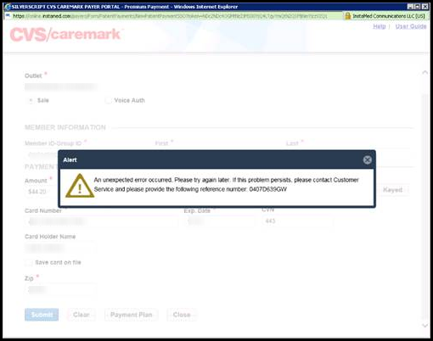

**Example 1**

**Example 1 -** If this Alert pops up, the **MED D CARE CCRs** should create a Support Task regarding the downtime issue and advise beneficiary you are requesting a confirmation of payment or automatic payment set-up due to a system error.

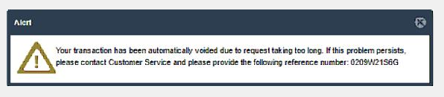

**Example 2**

**Example 2 -** If this Alert pops up, inform the beneficiary the payment was not successful due to a system issue. If an authorization is on their credit or debit account for this amount it will drop off as a **voided** transaction. **MED D CARE CCRs** would still create a Support Task regarding the downtime issue.

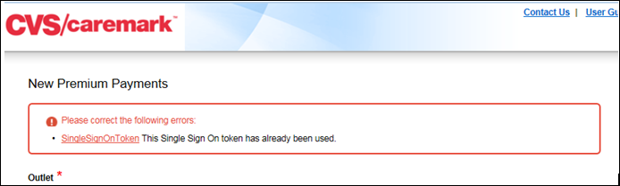

**Example 3**

**Example 3 -** If a message states that the “**Single-Sign-On Token**” is already used, this means a prior payment screen or receipt was not closed. Check **browser windows** for a receipt or payment screen and **close** it. This should clear this error.

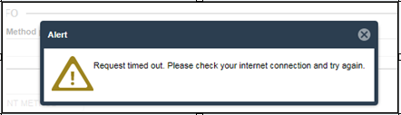

**Example 4**

**Example 4** - This error most commonly occurs when the ISP or local computer is experiencing connectivity issues and is resolved quickly. If you continue to experience this error, reach out to IT for additional troubleshooting. No payment or change will be processed.

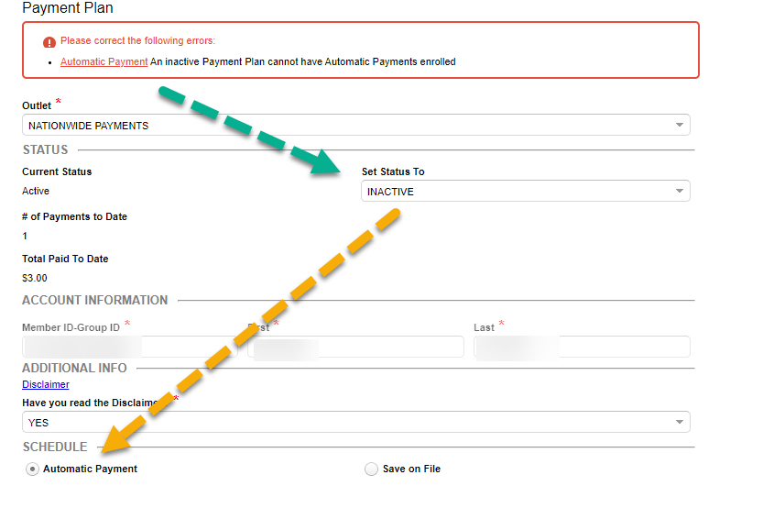

**Example 5**

**Example 5** - This error indicates the **Set Status To** selection is **Inactive**, but the **Automatic Payment** radio button is **selected**. To stop automatic payments, **both** the status and the radio button selection need to agree. Select the **Save on File** radio button when selecting Inactive status.

**Sycurio-specific Errors:**

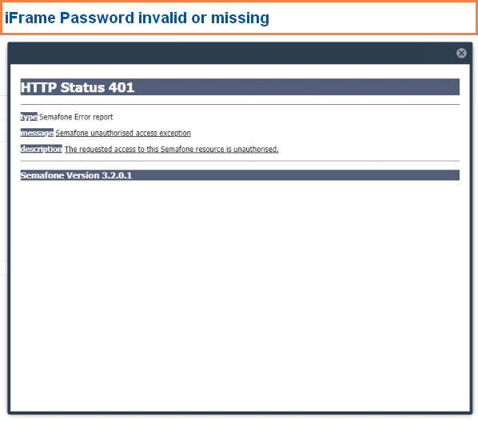

**Sycurio Error Example 1**

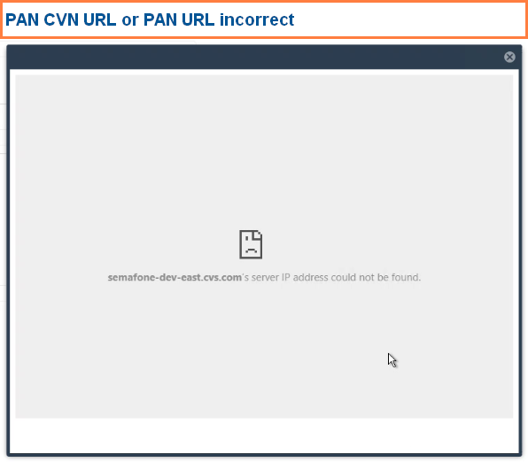

**Sycurio Error Example 2**

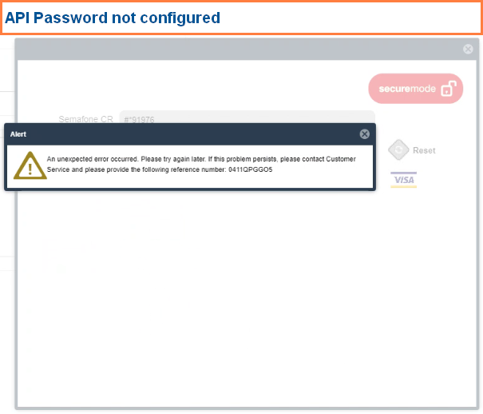

**Sycurio Error Example 3**

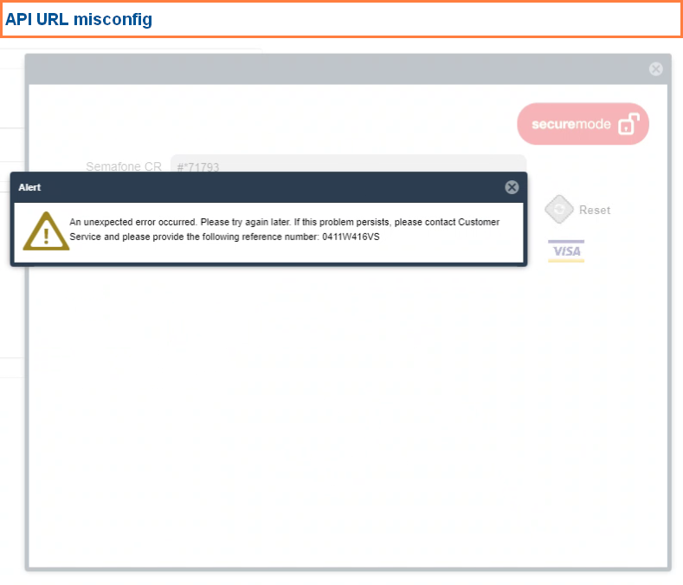

**Sycurio Error Example 4**

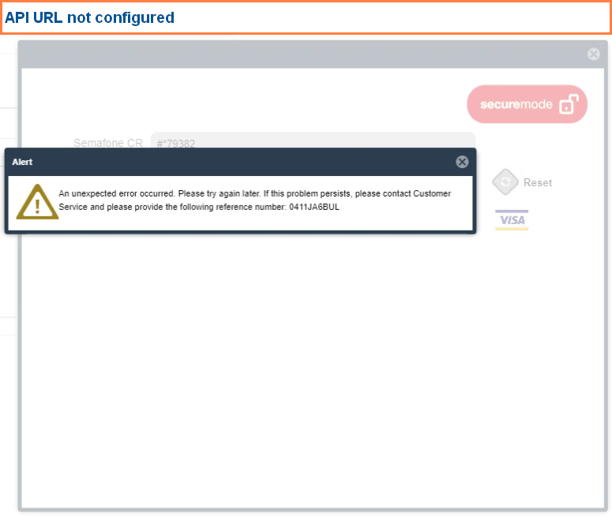

**Sycurio Error Example 5**

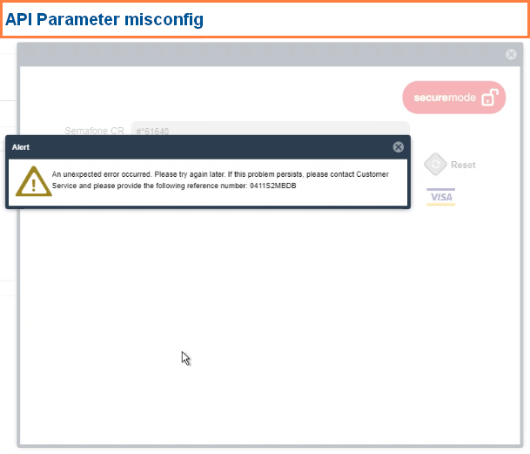

**Sycurio Error Example 6**

[Top of the Document](#_top)

|  |
| --- |
| Payment Single-Sign-On (SSO) System Fields & Rules |

Refer to the following list of **Payment Single-Sign-On (SSO)** **System Fields** (not all inclusive):

|  |  |
| --- | --- |
| **Single-Sign-On System Fields** | **Details** |
| Automatically Populated Fields:  (**Member ID-Group ID**, **First** and **Last Name**) | **Member ID-Group ID, First** and **Last Name** are automatically populated fields and are Read-only. CCRs should **always** **confirm** the ID and name **match** the beneficiary’s account being serviced. |
| **Cancel** Link | Users **do NOT use** the **Cancel** link in the Automatic payment screen (located in the NEXT TRANSACTION section).  **Notes:**   * If the **Cancel** link is clicked in error, the scheduled payment will reschedule itself if the **Automatic Payment** radio button is still selected and the status is still **Active**. * Cancelling a scheduled payment is not possible without setting the Automatic Payment Status to Inactive and selecting the **Save On File** radio button. This removes the payment method and returns the beneficiary to invoicing. |
| **Payment Method** | Users **do NOT use** the “**+ New Payment Method**” option on the One-Time Payment screen to change automatic payment source. This is a **one-time** use feature, and account information will **not** be stored.  **Notes:**   * If this is populated with payment method information, the beneficiary has a card or banking information on file for automatic payments. Close the current payment screen. Check the Automatic Payment screen for the status of the payment method on file. The status may be made Active or Inactive.  1. Active will populate the payment information on the one-time payment screen after updating and renew the automatic payments. 2. Inactive will remove the payment information on the one-time payment screen after updating and return beneficiary to invoicing. 3. Only select the **Automatic Payment** radio button if the beneficiary wants to use this method for automatic Medicare Prescription Payment Plan charges. |
| **Save** Button  (located on **One Time Payment** or **Automatic Payment** screens in **Payment Single-Sign-On (SSO)** system) | In order to complete a onetime payment or set up an automatic credit card payment use the **Save** button. After clicking Save, a Receipt pop-up window will appear. |
| **Close** Button (located on pop-up receipt screens) | Failure to **close** the Receipt pop-up window will keep the SSO token open and could cause your next beneficiary’s automatic payment request or payment to apply to the current beneficiary’s account. |
| **Set Status To** Field | Users **do not use** the **Complete** option for this field.  **Notes:**   * Verify and update **Set Status To** field to **Active** when [Updating Automatic Payments](#_Enrolled_Customer_Profile) information (must click the [Save](#Save)button afterwards). * Update **Set Status To** field to **Inactive** when [Cancelling Automatic Payments](#_Cancelling_a_Scheduled). |
| **Automatic Payment** radio button | If **status** is being set to **Active**, then select the **Automatic Payment** radio button.  If **status** is being set to **Inactive**, then select the **Save On File** radio button. Monthly payments will not schedule if the **Automatic Payment** radio button is not selected. |
| **Email Address** Field | The **Email** **Address** field is **optional**. Entering an email address in the payment screen will prepare the Single-Sign-On (SSO) system for a transaction receipt to be emailed to the beneficiary for a One-Time payment.   * Confirm the Email Address on the receipt and click **Send** to complete the email request. * The email will be sent from the payment processor (InstaMed) and may have a plan-specific header with “Powered by InstaMed” in the footer. * **Note:** If the beneficiary is unable to provide an email address, refer to the [FAQ](#OneReceipt) for the process to request a one-time payment receipt. |

[Top of the Document](#_top)

Refer to the Following **Payment Single-Sign-On (SSO)** **System Rules** (not all inclusive):

|  |  |
| --- | --- |
| **Single-Sign-On Rules** | **Details** |
| Confirmation Number (**Authorization Code** or **Payment Plan ID**) | A receipt will pop up displaying the **Authorization Code** (One-Time Payment) or **Payment Plan ID** (Automatic Payments). Provide beneficiary with this information as their Confirmation Number. The Confirmation Number provided **must** be documented in the case notes in **Compass**.  The **Authorization Code/Payment Plan ID** cannot be retrieved by Care once the pop-up receipt window is closed.  The **Authorization Code** for one-time card payments is generated by the card issuer. This code may be the same for similar transactions between beneficiaries with the same card issuer.  The **Authorization Code** for one-time E-Check payments is system generated, not a bank response. However, the code will be tied to the payment in InstaMed. (E-Check payments are not live transactions with the bank or financial institution. Approved status does not mean the payment is accepted by the bank/financial institution.) |
| Declined Credit Card on Automatic Payment | Status shows **Declined**.  If the beneficiary’s credit card is declined during an automatic payment charge or payment taken using card or banking information on file, the account will show **Declined** until the card number or expiration date is updated and the status is updated to **Active** using the Set Status drop-down. The **Automatic Payment** radio button must also be selected to fully activate automatic payments again. **Declined** status causes the account to be switched to direct bill until the credit card is updated and activated. |
| Expired or New Credit Card | * To update the beneficiary’s credit card, clear the credit card information and expiration date using the **Clear** button and add the new Credit Card, Expiration Date and Zip. Refer to the [Update Automatic Payment](#ProcAutomaticCCPremiumPayment) section of this document. * Verify the Member Name in the **SSO** screen matches the beneficiary’s account being serviced in **Compass**. * Ensure the **Set Status To** field is set to **Active** and the **Automatic Payment** radio button is selected prior to clicking on the [Save](#Save) button to ensure the updates are saved correctly. |
| Payment Method Change | Currently automatic check payments requesting automatic credit card payments.   * Changing the payment option to Automatic Credit Card from Automatic Check can take 1-2 billing cycles to begin charging, depending on timing and account status. Adding a card for automatic payments will update billing automatically, and no task is needed to stop check payments. * Beneficiaries will receive a confirmation letter (**Reference ID APCONF** in upper right corner, below the date) containing the date automatic credit card payments will be effective; advise the caller to continue to pay any invoices received. * With Automatic Check and Credit Card payments, the beneficiary’s entire balance is deducted each month. |
| Call Documentation Requirements | Must leave notes providing a clear picture of what transpired during the call and document the [Confirmation Number](#conf) provided on One-Time and Automatic Payments.  **Example 1:** Beneficiary contacted plan regarding recent letter for expired card, updated credit card number for auto payments with Discover Card ending in xxxx, Confirmation Number: #xxxxxx.  **Example 2:** Beneficiary gave permission for wife to make a one-time payment of $$.$$ with Visa Card ending in xxxx, Confirmation Number: #xxxxxx. |
| Caller requests changes to payments | Determine if the caller is authorized to make changes to the beneficiary’s account.   * Fully authenticated third party callers **CAN** still make one-time credit card or check payments to a beneficiary’s account because this will **NOT** change the account’s payment method. * If the caller is **NOT** the beneficiary, Ship Counselor, or Legal Representative, the automatic payment method **cannot be updated** without the beneficiary’s permission.   Refer to the [HIPAA Grid](https://thesource.cvshealth.com/nuxeo/thesource/#!/view?docid=5b354e50-0d15-42d0-b9c2-0711ea02d9ce). |

[Top of the Document](#_top)

|  |
| --- |
| Frequently Asked Questions |

Refer to the following Frequently Asked Questions:

|  |  |
| --- | --- |
| **Question** | **Answer** |
| How can a **CCR** void a One-Time Credit Card Payment placed in error? | **CCRs** **cannot** void payments. A Senior or Supervisor must be contacted for further assistance. Refer to the [Void One Time Credit Card Payment](#_VOID/Cancel_a_One-Time) section in this Work Instruction. |
| Where do CCRs view recent Medicare Prescription Payment Plan payments made on the account? | From the **M3P** tab in Compass, select the **Payment History** sub-tab to view past payments. |
| Where do users update expiring credit cards? | When a beneficiary calls to update credit card payment information, the CCR must clarify first whether the beneficiary wants to update Medicare Prescription Payment Plan payment information or Mail Service payment information.  For Medicare Prescription Payment Plan payments, the credit card is updated in the **Payment Single-Sign-On (SSO)** system. Refer to the [Updating Automatic Payment Information](#_Enrolled_Customer_Profile) section in this Work Instruction.   * For Mail Service Payments, the credit card is updated in **Compass**, refer to [Compass - Add, Edit, and Delete Mail Order Payment Methods (Credit Card & eCheck)](https://thesource.cvshealth.com/nuxeo/thesource/" \l "!/view?docid=5a1a67eb-a7b1-4ae5-bcfe-e986bbe4aa3d" \t "_blank). |
| What if the beneficiary calls to update only the expiration date of their credit card? | See [Expired or New Credit Card.](#expired) |
| Where do I put the **Security/CVV (Card Verification Value) code** from the card? | **There is no field for Security/CVV (Card Verification Value) code entry**, **never** request or note this code during payment processing or Autopay set-up/updates. |
| How can the beneficiary **update/remove their email address** on file for InstaMed payments? | **CCR Process Note:**  Currently, there is no option for the beneficiary to update/change an email address online. The CCR will create a **Support Task** requesting the member’s portal email address be updated:  **Task Type:** M3P - Billing Exception  **Exception Reason:** Other  **Task Notes:**  Document the following:   * Member has new email address for Member Portal Payment Receipts. New email is: [xyz@abc.com](mailto:xyz@abc.com) * Beneficiary’s contact number.   **Notes:**   * CCR will use this same Support Task Type to request a member’s email be **removed** from their Member Portal record. * Removing or changing an email address on a member’s profile or saved payment method will not remove any member portal login created with that email. InstaMed Support may be able to assist members with instruction on correcting any logins created with a bad email address. |
| What if the user unintentionally cancels the beneficiary’s scheduled automatic credit card payment for the month? | See [Cancel Link](#cancel). |
| Will the **Payment Single-Sign-On (SSO)** system time out? | Yes, if users switch to another application or window, after 15 minutes of idle time, the window may time out. |
| What happens if the **Payment Single-Sign-On (SSO)** system is not available (downtime)? | These instances should be rare, in the event this occurs verify what information has been communicated about the downtime. If no information has been communicated, users must follow the [Downtime Process](#_Downtime_Process) section of these Work Instructions and alert a Senior or Supervisor. |
| Why am I receiving the same **Confirmation Number** each month I make a one-time payment? | For credit card payments, the **Authorization Code** is generated by the card issuer. This code may be the same for similar transactions between beneficiaries with the same card issuer. |
| How do I know what day my payment method will automatically charge this month? | Payment methods set up for auto payments will charge on the **25th** of each month for the balance due on the account as of that month’s billing. |
| Do I need to invoke **Sycurio** to only update an expiration date? | Yes, the Sycurio feature locks the card and expiration date fields. CCRs with Sycurio role codes in Compass will need to invoke Sycurio with the **Phone** button and follow the process again with the card entry for payment if the incorrect expiration was entered. |
| What if a beneficiary wants to confirm active automatic payments or stop automatic payments? | Click the **Automatic Payment** button and verify the **status** is “Active” and the **Automatic Payments** radio button is selected. These **both** must be true.   * **Close** pop-up screen if no changes are needed, and automatic payments are active. * Select **Active** Status, select **Automatic Payments** radio button and click **Save**. |
| Can a debit/credit card payment (one-time or autopay) be refunded back to the card used? | Yes, refunds processed back to debit/credit cards **must** be for the **full amount** of the **original charge**; credit may take 5-7 business days to apply to the card account, depending on bank processes. **Partial** refunds will be processed by **manual check** refund with 21 business day TAT. |
| Does a beneficiary receive an email when a recurring payment is taken each month? | There is not an email generated each month for recurring automatic payments. The only time an email is sent will be by member request to CCR. CCR will create the below Support Task for a receipt copy.  **Task Type:** M3P - Billing Exception  **Exception Reason:** Invoice Statement Request  **Task Notes:** Document the following:   * + - Confirming automatic payment charge this month. Please email receipt.     - Beneficiary’s email address.   **Note:** Offer beneficiaries self-service option of creating a secure login to the **WIPRO Member Portal.** They will be able to view autopayment receipts in their portal dashboard. |
| Can I request a one-time payment receipt be emailed to me? | Create the following Support Task:  **Task Type:** M3P - Billing Exception  **Reason for Dispute:** Invoice Statement Request  **Task Notes:** Document the following:   * Member would like a receipt for payment of <$XX.XX> received on <MM/DD/YYYY> to be emailed to them at <enter email address>. * Beneficiary’s contact number. |

[Top of the Document](#_top)

|  |
| --- |
| Resolution Time |

The beneficiary can make a One-Time Payment **OR** have a payment method on file for Automatic Payments monthly.

* Payments will be visible in **Compass** in real time. For payment disputes, Care should always open a Support Task with details of the dispute.

**Task Type:** M3P - Billing Exception  
**Exception Reason:** Payment Research

**Task Notes:** Document the following:

* + Provide details of the beneficiary’s concern(s).
  + Beneficiary’s contact number.

**Note:** Turn Around Time (TAT) for resolution of this Support Task Type is 5 business days. A plan representative will contact the beneficiary with research results. (Confirm phone number is current).

[Top of the Document](#_top)

|  |
| --- |
| Related Documents |

Refer to [Compass MED D - Billing, Payments, & Forecasting - Medicare Prescription Payment Plan](https://thesource.cvshealth.com/nuxeo/thesource/#!/view?docid=955acdc4-aa21-499b-8481-41a58f44cc20)

**Parent Document:** CALL-0048:[Medicare Part D Customer Care Call Center Requirements-CVS Caremark Part D Services, L.L.C.](https://policy.corp.cvscaremark.com/pnp/faces/DocRenderer?documentId=CALL-0048)

**Abbreviations/Definitions:** [Customer Care Abbreviations, Definitions, and Terms](https://thesource.cvshealth.com/nuxeo/thesource/#!/view?docid=c1f1028b-e42c-4b4f-a4cf-cc0b42c91606)

[Top of the Document](#_top)

Not to be Reproduced or Disclosed to Others without Prior Written Approval

**ELECTRONIC DATA = OFFICIAL VERSION / PAPER COPY = INFORMATIONAL ONLY**